Tutorial – 8.2

**Aim:** Write a shell script to validate the entered date (eg. Date format is: dd-mm-yyyy)

**Code:**#!/bin/bash

echo "Enter a date (format: dd-mm-yyyy):"

read date_string

if [[ $date_string =~ ^[0-9]{2}-[0-9]{2}-[0-9]{4}$ ]]; then

day=$(echo "$date_string" | cut -d'-' -f1)

month=$(echo "$date_string" | cut -d'-' -f2 | sed 's/^0*//')

year=$(echo "$date_string" | cut -d'-' -f3)

if [[ $day -ge 1 && $day -le 31 && $month -ge 1 && $month -le 12 && $year -ge 1000 && $year -le 9999 ]]; then

echo "The date '$date_string' is valid."

else

echo "Error: Invalid date '$date_string'."

fi

else

echo "Error: Invalid date format. Please enter the date in the format dd-mm-yyyy."

fi

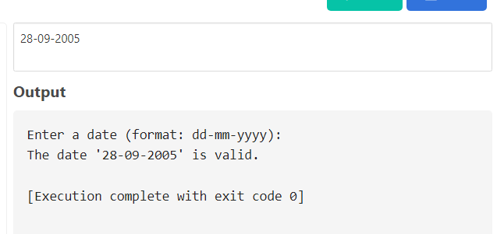**Output:**